**IST 718 Project Checkpoint 2**

**Specification—What problem are you attempting to solve?**

We are attempting to accurately detect cases of COVID-19 using x-ray images of patients’ chests.

**Observation—What have you observed thus far in the data?**

Our first few steps of exploratory data analysis have yielded some cursory insights. The figures below show the average image of a normal lung and a COVID-19 positive lung.

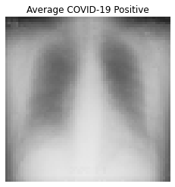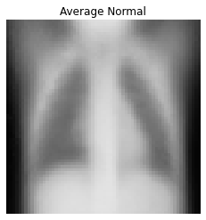

The next figure shows the differences between the two averages. The average COVID-19 lung x-ray shows more inflammation at the bottom of the lung compared to the average normal lung x-ray. This is highlighted in blue.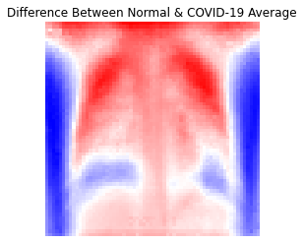

Related to the data pre-processing, one thing we noted was that the training dataset has a lot of medical markings**.** We will need to figure out a way to remove these before feeding the images into our model.

**Analysis—What modeling techniques will you use?**

We are attempting to apply transfer learning.

**Recommendation—What work do you still have to do?**

We are still working on a meta dataset, and need to clean the training dataset of medical markings, finalize the model, and train on the whole set.